**Reference:**

**We relied on the connections and code on this website :** [**https://randomnerdtutorials.com/esp32-microsd-card-arduino/**](https://randomnerdtutorials.com/esp32-microsd-card-arduino/)

**Connections:  
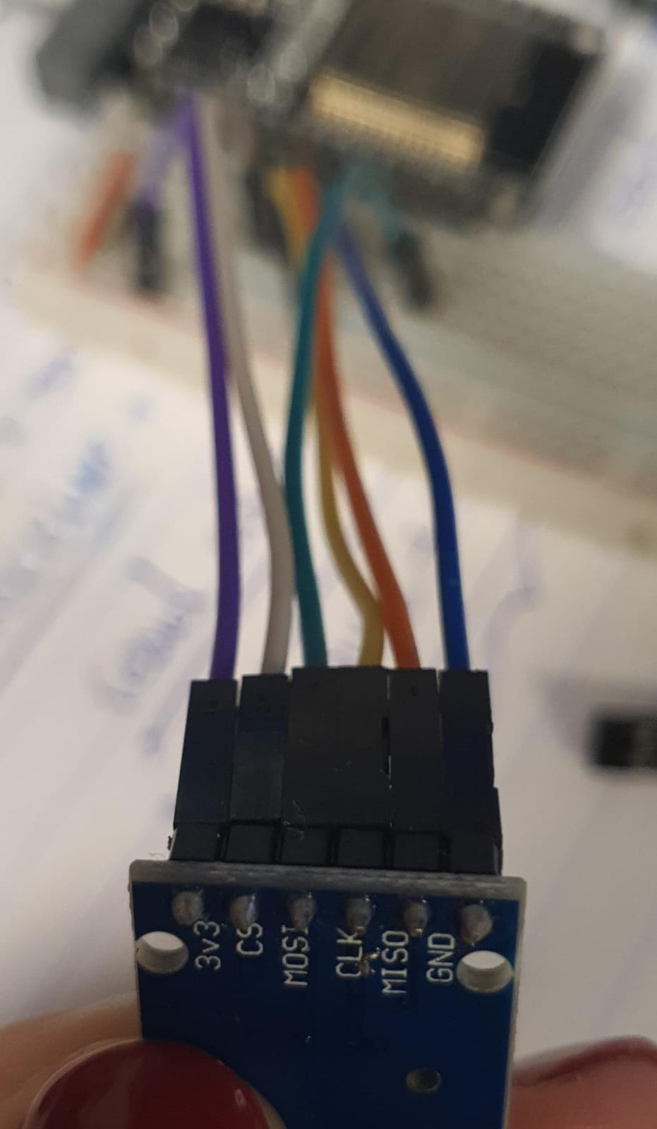**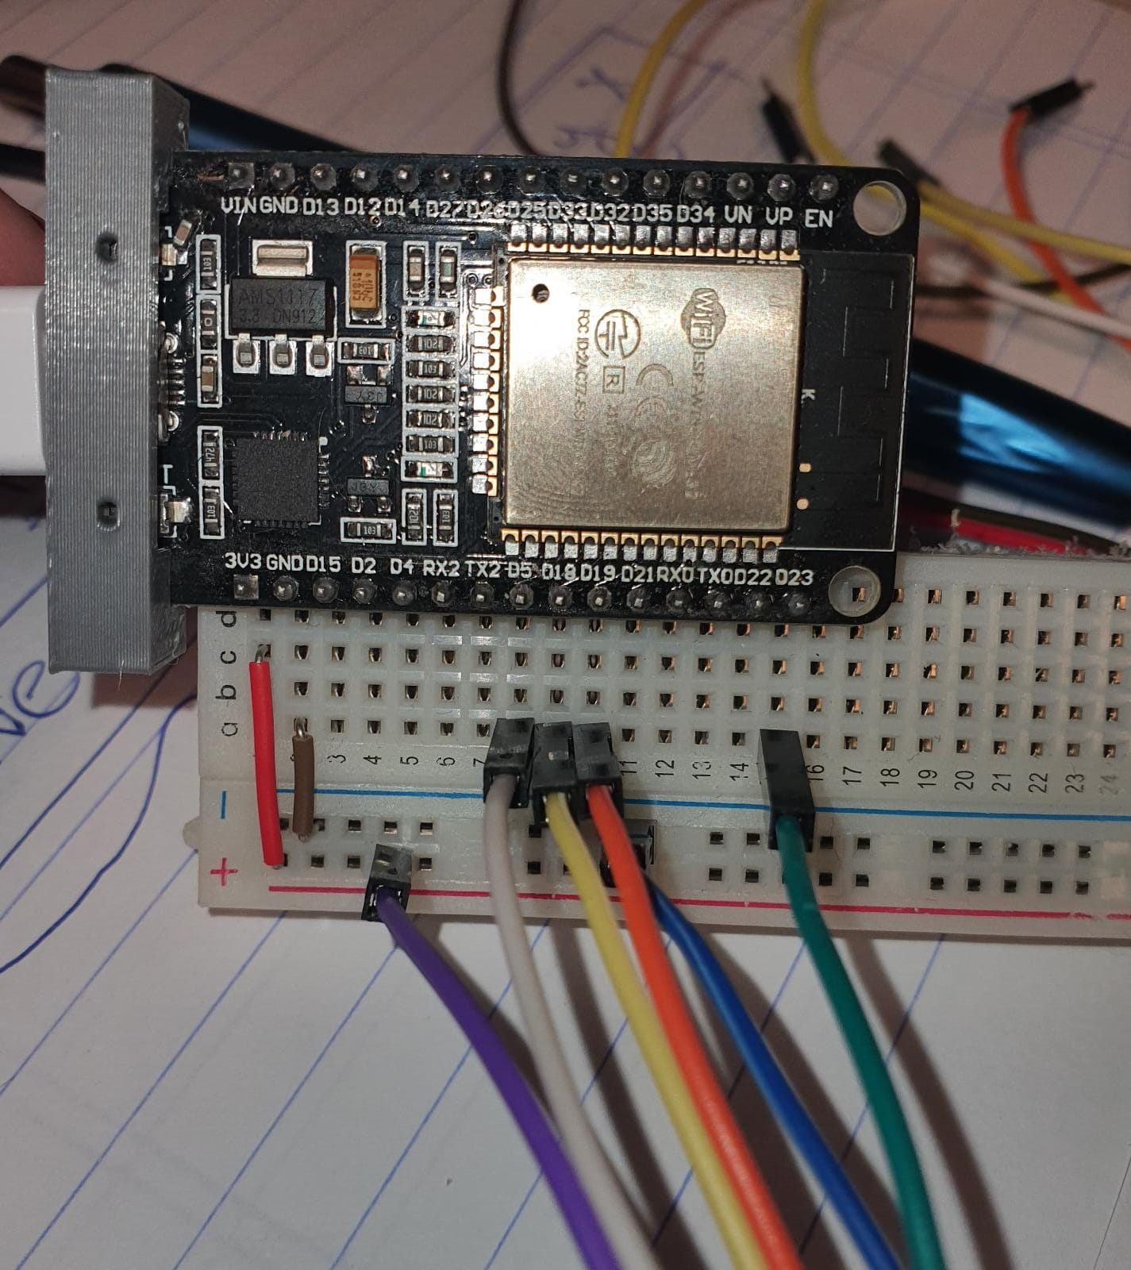

PINS:

3V3 - 3V3

CS - 5

MOSI - 23

CLK - 18

MISO - 19

GND - GND

**Notice in the code (SD_test) you have to declare :

#define SCK 18

#define MISO 19

#define MOSI 23

#define CS 5

SPIClass spi = SPIClass(VSPI);

And initialize the SD card as

SD.begin(CS,spi)

**When using the LoRa32:**

Look for the pins that use the SPI protocol and connect them (can be either vspi or hspi, it’s the same dw), dont forget to change the declaration of the pins in the code (SCK, MISO, MOSI, CS).